REPUBLIC OF THE PHILIPPINES

CEBU TECHNOLOGICAL UNIVERSITY
ARGAO CAMPUS
Ed Kintanar St. Lamacan, Argao, Cebu, Philippines Website: http://www.argao.ctu.edu.ph Email:cdargao@ctu.edu.ph
Phone No.: (032) 485-8290/485- 5109 loc 1700 Fax No. (032)-4858-290

O F F I C E O F T H E S T U D E N T L I F E

present this
POGI OF THE YEAR
to

CHRISTIAN ABREGANA
in recognition of her exceptional leadership skills, exemplary dedication, and outstanding contribution as the President of the Equationers during the Academic Year 2023-2024.

Given this June 13, 2024, during the Ring Hop Ceremony and tribute to Parents held at CTU-AC Kalampusan Gym.


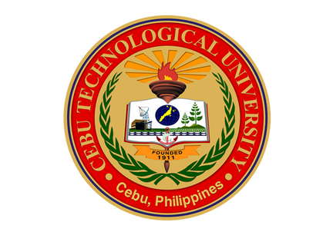

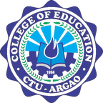
MELANIE R. ALBARRACIN
Dean, Student Life
EINGILBERT C. BENOLIRAO
Campus Director

